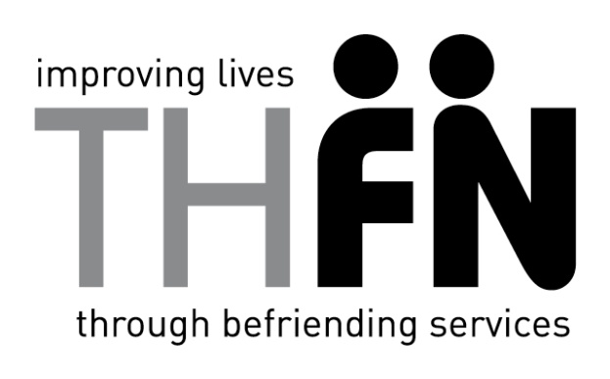
 | Application Form
 | Position: | Volunteer Befriender
 | Section 1: Personal Details
 | Surname
 | First name
 | Home Address
 | Home telephone |  |  |  |  |  |  |  |  |  |  |  |  | Mobile
 | Email address
 | Alt email address
 | Current Employment Details |  |  | Name of Employer  Your role (please give a brief description of what you do):  From: To:
 | Are you eligible to work in the UK? (Please delete) |  |  | Yes |  |  | Date of birth
 |  |  |  | No
Section 2: Skills and Experience
Please describe any skills, training and experience (paid/unpaid) that you have which you feel is relevant to volunteering with us.
Section 3: Volunteering Activities
Which of the following activities would you like to be involved in ?

Befriending in home Office/Telephone Befriending Escort to Outings

Section 4: Referees
Please give details of two referees who we can contact to ask about your suitability as a volunteer with us.
One should be your current or last employer , if possible, or a teacher, tutor or volunteer manager.
1: Name |  | 2: Name
Address |  | Address
Telephone No |  | Telephone No
Email Address |  | Email Address
Capacity in which known to applicant |  | Capacity in which known to applicant
Time known to applicant |  | Time known to applicant

Section 5 :Availability

We generally need volunteers to be able to commit to at least one hour per week, between 9.00 am and 5.00pm Monday to Friday, although there are volunteer request for evening visits and some weekend visits too. An initial six month commitment is required. What days times are you available to volunteer?

_____________________________________________________________________________________

Section 6: Where did you hear about us? _____________________________________________

Section 7: Signature and Declaration

For roles involving contact with vulnerable adults you will be required to have an enhanced Disclosure and Barring Service (DBS) check before you can start.
A criminal record is not necessarily a bar to volunteering with us. Volunteers must be 18 years or older.
Please sign below to confirm that the information given in this application is, to the best of your knowledge, true and accurate.
I certify that the information given on this form is correct and understand that any misleading information or deliberate omissions will be grounds for termination of my volunteer work with THFN.
Signature |  | Date

